EZPZ Review: Unit 1
This is called an “E-Z-P-Z” Review. This review only hits the basic and foundation of the unit.
The extended and more difficult questions were on your QUEST homework so look there!
This is just to make sure you at least know the basics!

- Consider the results of three students who repeatedly weighed a lead block known to have a true mass of 10.00 g (indicated by the solid horizontal blue line on the graphs).
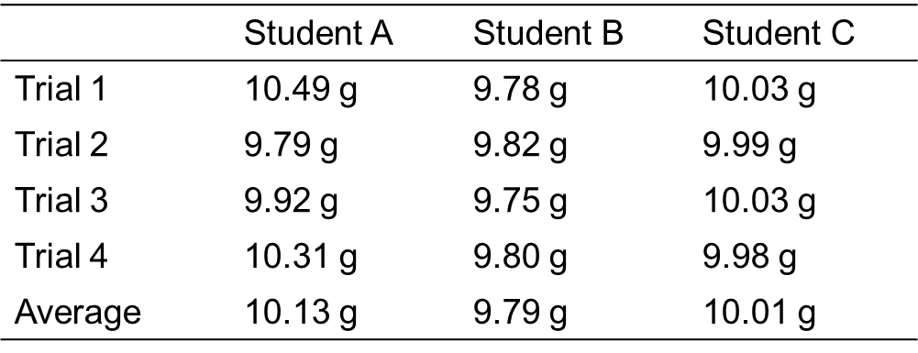
  - Which student was both inaccurate and imprecise?
  - Which student was accurate and precise?
  - Which student was inaccurate, but precise?

- Measure or calculate to the correct number of significant figures:

  - 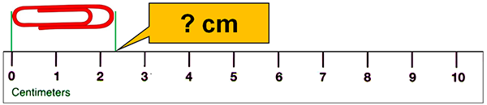

  - 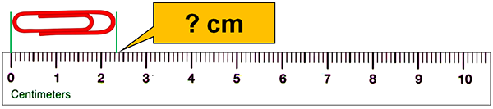

  - 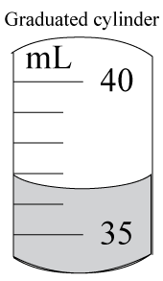

  - 0.355 + 105.1 – 100.5820 =

  - 2.345 + 0.07 + 2.9975 =

  - 2.380 x 7.1 =
  - (3.102 – 1.23) /0.782 =

  - 5.6 x 2.12 – 1.05 =
  - [(1.428 – 1.08)/0.288] + (2.83 x 0.360) =

- A student measured a mass to be 250. But the actual mass was 240. g. What is the percent error (in the correct number of sig figs)?

- Convert:
  - 592 μm to mm
  - 2.31 kg to g
  - 0.980 dL to cL

- States of Matter: Matching! Label each property as solid (s), liquid (l), or gas (g). Some questions may have more than one correct answer! Each answer may be used more than once!

- _____ Particles take the shape of their container.
- _____ Particles have definite volume.
- _____ Particles have indefinite volume.
- _____ Particles may easily be squished closer together.
- _____ Particles keep their own shape no matter what container they’re in.
- _____ Particles have definite shape.
- _____ Particles are the least compressible.
- _____ Particles spread out to fill their entire container.
- _____ Particles of the substance are dissolved in water.
- _____ Particles flow past each other.
- _____ Particles are the most compressible.
- _____ Particles have indefinite shape.
- _____ Particles move all over.
- _____ One example is paper.
- _____ Particles keep their own volume no matter what container they’re in.
- _____ Particles cannot be squished closer together.
- _____ Particles can compress to fit into a smaller container.

- s) t)

- Identify each of the following as: element (E), compound (C), heterogeneous (He) or homogeneous (Ho).

- Air ___________
- Chlorine (Cl₂) ___________
- Carbon dioxide (CO₂)__________
- Granite _________
- Salt Water ___________
- Liquid nitrogen (N₂) ___________
- Concrete ___________
- Apple Juice ___________
- Sand ___________
- Glucose ___________
- Carbon (C) ___________
l) Pure water ___________

- Classify whether the picture is a pure substance (element/compound) or mixture (homo/hetero):
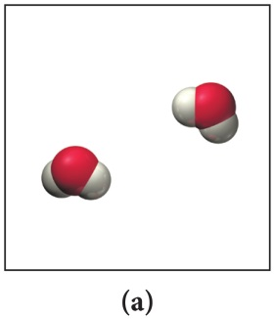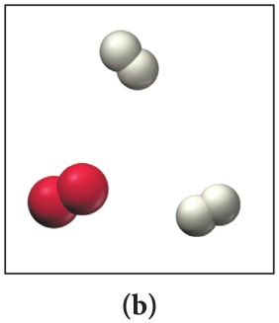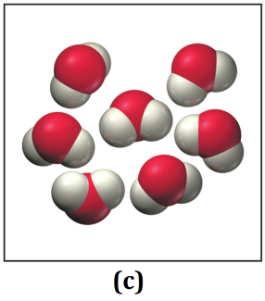

- Determine if it is a physical or chemical change.
- Iron rusts from exposure to the oxygen gas in the air, forming reddish brown flakes.
Fe(s) + O₂(g) → FeO₂(s)

- Delicious sugar (glucose) is dissolved into tea.
C₂₂H₁₈O₁₁(aq) + C₆H₁₂O₆(s) → C₂₂H₁₈O₁₁(aq) + C₆H₁₂O₆(aq)

- Hydrogen peroxide decomposes into hydrogen gas and oxygen gas.
H₂O₂(l) → H₂(g) + O₂(g)

- Ethanol evaporates.
C₂H₆O(l) → C₂H₆O(g)

- Determine if it a physical OR a chemical property. Determine if it is an extensive OR an intensive property.
Property | Physical Property | Chemical Property | Extensive Property | Intensive Property
magnetism
malleability (can be hammered thin without breaking)
temperature
flammability
red color
reacts violently with sodium
length
mass
produces a different gas when heated
dissolves in water
rough texture
sweet taste
density
toxicity
sour taste
melting point
boiling point
hardness
luster (how shiny it is)
odor

- Density:
  - Calculate the density of mercury if 1.00x10² g occupies a volume of 7.36 cm³.
  - What is the volume of water if the mass of water in a container is 212.1g?
    - What is the density of water?
    - Would charcoal float in water? (Use the chart below)
  - If the mass of an unknown object is 115.92g and the volume is 6.00cm³, what is the density?
    - Using the chart below, identify the unknown object.

