EZPZ Review: Unit 2 (The Atom and Moles)
This is called an “E-Z-P-Z” Review. This review only hits the basic and foundation of the unit.
The extended and more difficult questions were on your QUEST homework so look there!
This is just to make sure you at least know the basics!

Part 1: History

- Who bombarded gold foil with alpha particles?

- Who devised the first atomic theory?

- Who developed the planetary model of the atom?

- Who discovered the first subatomic particle?

- Who discovered the nucleus?

- Who devised the plum pudding (chocolate chip cookie) model?

- Who was the first to suggest electrons had a fixed energy?

- Who said that all atoms of an element are identical in size, mass and other properties?

- Who determined that the mass of an atom was concentrated in the center?

- Who showed cathode rays are composed of negative particles?

- Who discovered the atom is made up of mostly empty space?

- Who had the idea of a basic indivisible particle?

- Who concluded that all elements contain electrons?

- Who said atoms are neither created, nor destroyed—just rearranged?

Part 2: Structure of the Atom/Isotopes
Isotope name | Atomic # | Mass # | # protons | # neutrons | # electrons
magnesium–24
$${}_{12}^{26}{Mg}$$
$${}_{18}^{40}{Ar}$$
Ar–36
fluorine–19

1) What are subatomic particles? Which subatomic particles are in the nucleus?

2) Use the following answer choices to match the following statements:

(A) ${}_{5}^{11}B$ and ${}_{5}^{10}B$

(B) ${}_{6}^{12}C$ and ${}_{3}^{6}{Li}$

(C) ${}_{7}^{15}N$ and ${}_{5}^{11}B$

(D) ${}_{3}^{7}{Li}$ and ${}_{8}^{18}O$

(E) ${}_{7}^{14}N$ and ${}_{6}^{13}C$

Same number of neutrons
Difference of 1 proton
Number of protons of one isotope equals mass of the other isotope
Same number of protons
Difference of 6 neutrons

Part 3: Coulomb’s Law
- What are the 2 different types of energy that are considered between 2 charges?

- What is the relationship between charge and energy?

- What is the relationship between distance (r) and energy?
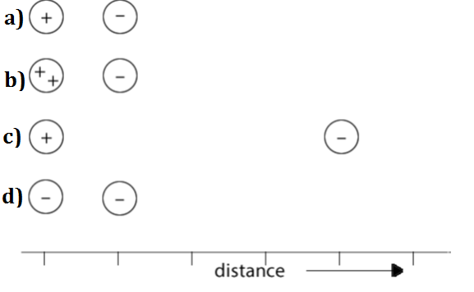
- Using the image to the right, answer the following:
  - Which set of particles will experience the smallest attraction from each other?
  - Which set of particles experiences the greatest overall energy, regardless of type?
- Would an electron be most attracted to the nucleus of a magnesium, strontium, calcium, or barium atom?s

Part 4: Average atomic mass

Naturally occurring gallium is a mixture of isotopes that contains 60.11% of Ga-69 (atomic mass = 68.93 u) and 39.89% of Ga-71 (atomic mass = 70.92 u). What is the atomic mass of naturally occurring gallium?

Three isotopes of argon occur in nature: ${}_{}^{36}{Ar}, {}_{}^{38}{Ar}, {}_{}^{40}{Ar}$. Their percent abundances are 0.3 %, 0.1 %, and 99.6%, respectively. Calculate the average atomic mass of argon to 2 decimal places.

Naturally occurring boron is 80.20% boron-11 (mass of 11.01 amu) and 19.80% of some other isotopic form of boron. What must the atomic mass of the second isotope be if the average mass is 10.81 amu?

- Use the mass spectrum for naturally occurring Rubidium to determine the average atomic mass. The intensity of the heavier isotope is determined to be 36%.
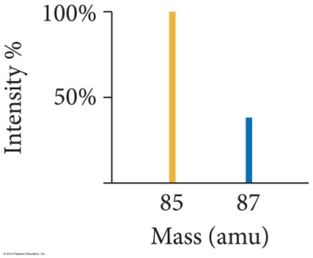

Part 5: MOLES

- Adam made an aluminum sculpture which weighed 45.22 g. How many atoms of aluminum did Adam use?

- Ariana made her aluminum sculpture out of 0.78 moles of aluminum atoms. What is the mass of her sculpture?

- Carmen has one pure copper penny (pre-1982) that weighs 3.11 grams. How many of these pennies would she need to have 2 moles of copper?

- If you have a balloon filled with 0.25 grams of argon gas, how many atoms of Ar are in your sample?

- If you have a gas canister that contains 1.08 x 10²³ atoms of neon, what is the mass of the neon gas?

- What is the molar mass of potassium? ______________________

- You have inherited an ugly silver bracelet from your great aunt that has a mass of 65.3 grams. How many moles of silver are in the bracelet?

- How many moles of cobalt would be found in a 23.2 g sample?

- How many grams are in 1.43 x 10²⁴ atoms of sulfur?

- A large iron nail has a mass of 12.87 g. How many atoms of iron are present in this sample?

- What is the molar mass of barium? ______________________

- What is the molar mass of an element if a 5 moles sample of the element has a mass of 80 grams?

- You are given a 3 mole sample of an unknown element. Your sample has a mass of 120 g.
  - What is the molar mass of your unknown element?

  - What is the identity of this element? ______________________

