How to Graph Your Data
- Open the Google Sheets app
- Under Start a new spreadsheet, select Blank
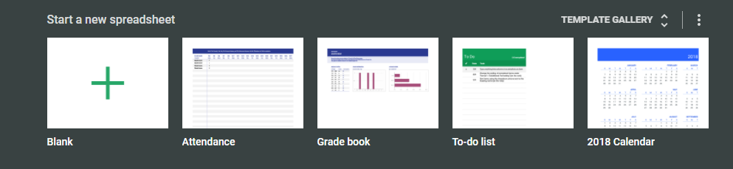
- In the top left cell (A1), put the header “NaOH added (mL)”
- Enter your volume values down the rest of the column
  - Do NOT copy my values – they are fabricated values
  - Enter all of the volume measurements that you have, in order
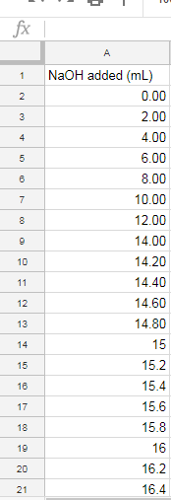
- In the top cell of column B (B1), put the header “pH”
- Enter all of your pH values down the rest of the column
  - Do NOT copy my values – they are fabricated values
  - Enter all of the pH values that you have, in order
  - Be sure each pH matches the volume it is next to
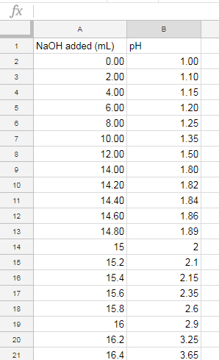
- When all of your data is entered, select the entire area containing your headers and data
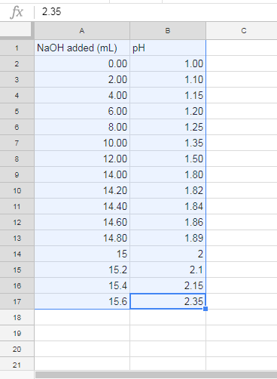
- Select “Insert” in the menu bar, then select chart
- Use the dropdown menu to change chart type to “Scatter chart”
  - X-Axis should already be set to NaOH added (mL) – if not, enter this
  - Series should already be set to pH – if not, enter this
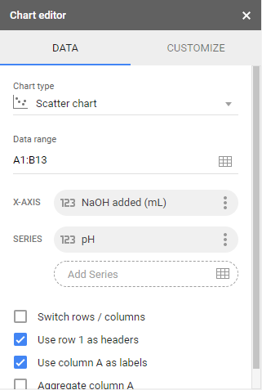
- Close out the Chart editor
- If you are satisfied with your graph, use the Snipping Tool to select it
- Paste your graph (Ctrl + V) into your lab report in the appropriate place

