Unit 10: Solutions

Pre-AP Chemistry Free Response Review #1

Directions: The suggested time is about 15 minutes for answering the constructed response section of the chemistry test. The parts within a question may not have equal weight. For calculations, show all your work in the spaces provided after each part. Pay particular attention to the proper use of units. Be sure your final answer is rounded to the correct number of significant figures. Make sure your work is legible. Illegible work will receive a grade of zero.
Question 1 [10 POINTS]

A 0.150 g sample of lead (II) nitrate is added to 125 mL of 0.100 M sodium iodide solution. The sodium iodide was added in excess. Assume no change in volume of the solution.
The molar mass of lead (II) nitrate is 331.22 g/mol.
- Write the balanced equation for this reaction, including states of matter. [3 POINTS]
- List an observation providing evidence of a chemical reaction between the two compounds. [1 POINT]
- Write the balanced net ionic equation that best represents this reaction. [1 POINT]
- Calculate the molar concentration of NO₃–(aq) in the mixture after the reaction is complete. [2 POINTS]
- Circle the diagram below that best represents the results after the mixture reacts as completely as possible. Explain the reasoning used in making your choice. [2 POINTS]
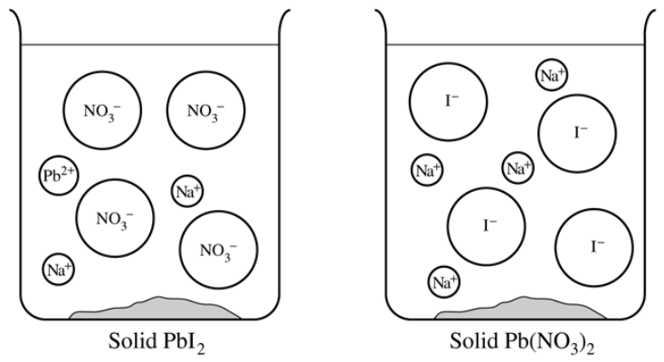

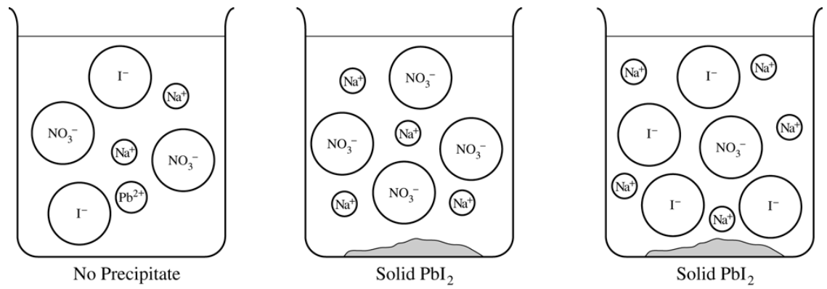

- How many total moles of ions will form if 5.00 moles of lead (II) nitrate dissolves in water? [1 POINT]

