___ - ___ - ___ = ___ /10
INCORRECT
SIG FIGS
INCORRECT
UNITS

Unit 12 Exam
Free Response Review #1

Pre-AP Chemistry
Directions: The suggested time is about 15 minutes for answering the constructed response section of the chemistry test. The parts within a question may not have equal weight. For calculations, show all your work in the spaces provided after each part. Pay particular attention to the proper use of units. Be sure your final answer is rounded to the correct number of significant figures. Make sure your work is legible. Illegible work will receive a grade of zero.

Question 1 [4 POINTS]
The following is a heat curve for chloroform, a solvent for fats, oils, and waxes. It is an organic compound with formula CHCl₃. The heating curve for a 1.50 mol sample of chloroform is shown below.

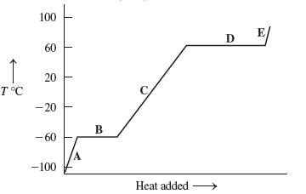
- Label each section of the graph with states and phase change (if applicable): [1.5 POINTS]

A:
B:
C:
D:
E:

- Determine the boiling point of chloroform. [0.5 POINTS]

- Calculate the amount of heat needed to completely vaporize a 1.50 mol sample of liquid chloroform originally at −60.0°C. The specific heat capacity of the substance in the liquid phase is 0.965 J/(g°C), and the heat of vaporization of the substance is 32.5 kJ/mol. [2 POINTS]

Question 2 [6 POINTS]

Heats of Formation
Iron (III) oxide | Fe₂O₃ | −824.2 kJ/mol
Carbon monoxide | CO | −110.5 kJ/mol
Carbon dioxide | CO₂ | −393.5 kJ/mol

Iron (III) oxide reacts with carbon monoxide to create solid iron and carbon dioxide gas as shown below:

Fe₂O₃ (s) + 3 CO(g) 2 Fe(s) + 3 CO₂(g)

- Use the heats of formation in the chart above to determine the heat of the reaction, ΔH_{rxn}.
[2 POINTS]

- Is the reaction endo or exothermic? Justify your answer. [1 POINT]

- Write the complete thermochemical equation for the reaction. [1 POINT]

- How much energy is absorbed/released if 2.00 moles of carbon monoxide reacted with iron (III) oxide? [2 POINTS]

