___ - ___ - ___ = ___ /10
INCORRECT
SIG FIGS
INCORRECT
UNITS

Unit 12 Exam
Free Response Review #2

Pre-AP Chemistry
Directions: The suggested time is about 15 minutes for answering the constructed response section of the chemistry test. The parts within a question may not have equal weight. For calculations, show all your work in the spaces provided after each part. Pay particular attention to the proper use of units. Be sure your final answer is rounded to the correct number of significant figures. Make sure your work is legible. Illegible work will receive a grade of zero.

Question 1 [3 POINTS]
A 1.5 g iron nail is heated to 95.0°C and placed into a beaker of water.

- Calculate the heat gained by the water (in kilojoules) if the final equilibrium temperature is 57.8°C. The specific heat capacity of iron = 0.449 J/g° C, and the specific heat capacity of water = 4.18 J/g °C. [3 POINTS]

Question 2 [7 POINTS]
Hydrochloric acid, HCl, and sodium hydroxide undergo a neutralization reaction, with ΔH_{rxn} = −57.9 kJ/mol_{rxn}.
- Write the balanced thermochemical equation for this reaction. [2 POINTS]

- Sketch a potential energy diagram for this reaction on the axis below. [1 POINT]

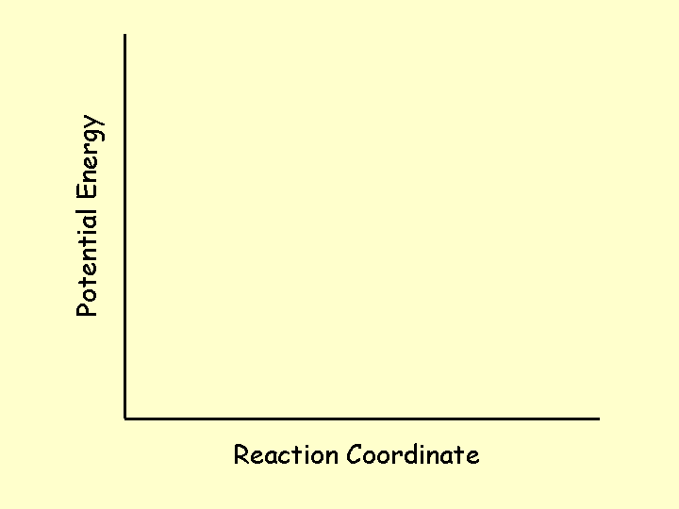
- When the two reactants are mixed, does the temperature of the water they’re dissolved in increase, decrease, or stay the same? Justify your answer. [1 POINT]

- Given the heats of formation provided in the table, calculate ΔH_{f} of sodium hydroxide. [3 POINTS]
Heats of Formation
Hydrochloric acid | −167.2 kJ/mol
Water (l) | −286 kJ/mol
Sodium chloride | −788 kJ/mol

