Unit 2: Atomic Theory, the Nuclear Atom and the Mole

Multiple Choice Practice
Directions: Each of the questions or incomplete statements below is followed by four suggested answers or completions. Select the answer that is best in each case and then fill in the corresponding circle on the answer sheet.

Note: For all questions, assume that the temperature is 298K, the pressure is 1.00 atmosphere, and solutions are aqueous unless otherwise specified.

1
2
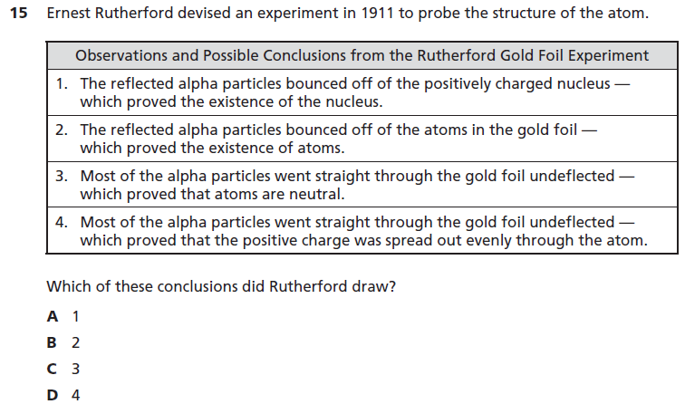
3
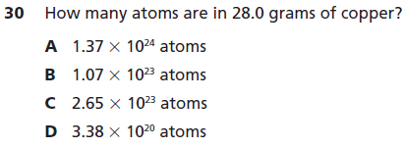

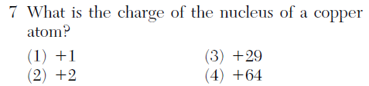
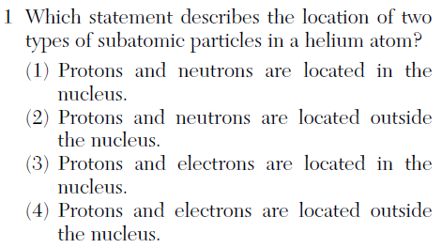
5
4
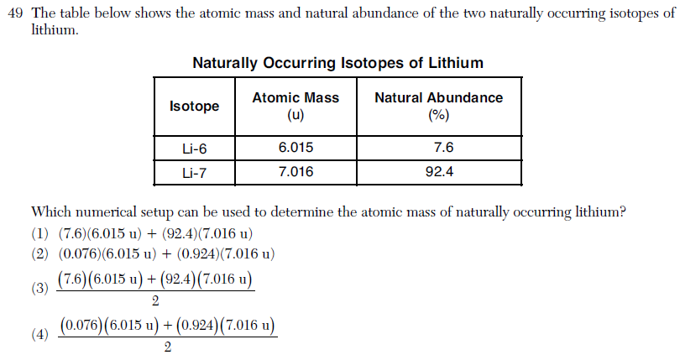
6

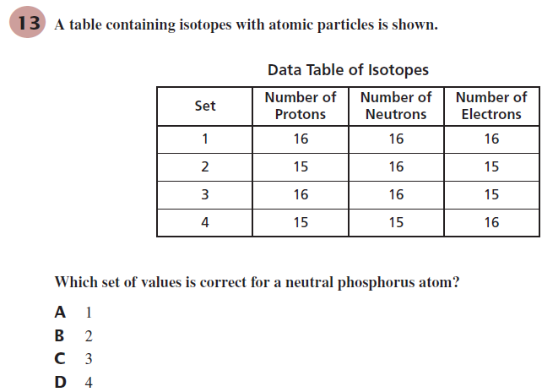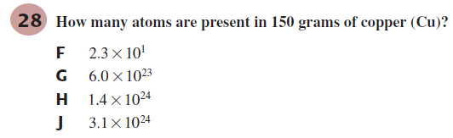
8
7
ACT Passage
People use many different chemicals each day for common household tasks such as cleaning and food preparation. Since the inception of consumer protection laws, chemicals come with toxicity warning labels, directions about proper use, and cautions about the hazards of improper use. Some household chemicals can be quite dangerous, especially when mixed together. One such example is the reaction that occurs when mixing household bleach (NaOCl) with ammonia (NH₃). The by-products of the reaction vary depending on the concentrations of the reactants. The following experiments were conducted to determine the levels at which certain by-products resulted from mixing bleach and ammonia.

Experiment 1
A known by-product of the reaction of bleach and ammonia is chlorine gas (Cl₂). Chlorine gas has an intensely disagreeable suffocating odor, and is very poisonous. To determine the quantities of bleach and ammonia that, when mixed together, produce chlorine gas, a varying quantity of bleach was added to eight different ammonia–water solutions and the resulting chlorine gas from each mixture was collected and measured. A solution of 1.0 mole (mol) of NH₃ in 1 kg of water was used in each trial. A certain quantity of NaOCl was added to each of the solutions; the amount added was gradually increased for each trial. The amount of chlorine gas produced in each trial was recorded and graphed in Figure 1.
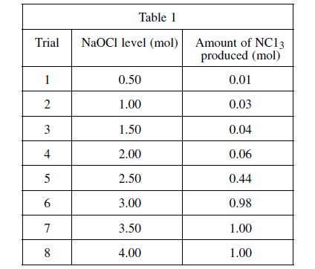
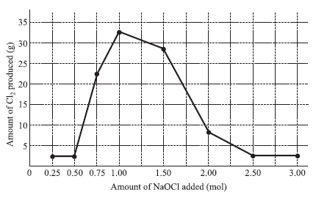
Figure 1
Experiment 2
Another known by-product of the reaction of bleach and ammonia is nitrogen trichloride (NCl₃). Nitrogen trichloride is a yellow, oily, pungent-smelling liquid, often found as a by-product of chemical reactions between nitrogen containing compounds and chlorine. It is highly explosive. To determine the quantities of bleach and ammonia that, when mixed together, produce NCl₃, again a varying quantity of bleach was added to eight different ammonia–water solutions and the resulting NCl₃ from each mixture was measured. A solution of 1.0 mole (mol) of NH₃ in 1 kg of water was used in each trial. A certain quantity of NaOCl was added to each solution; the quantity added was gradually increased for each trial. The amount of nitrogen trichloride produced in each trial was recorded (see Table 1).

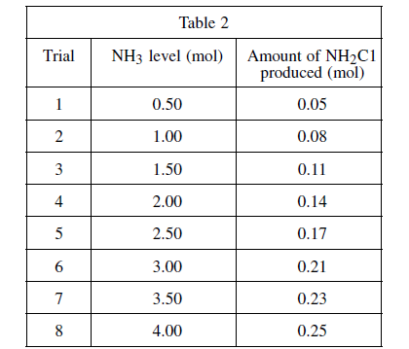
Experiment 3
In yet another reaction, bleach and ammonia combined under certain conditions produce a compound known as chloramine. Chloramine (NH₂Cl) is a toxic substance commonly used in low concentrations as a disinfectant in municipal water systems as an alternative to chlorination. To determine the mixture of bleach and ammonia at which NH₂Cl is produced, a varying amount of ammonia was added to eight different bleach–water solutions and the resulting chlorine gas from each mixture was collected and measured. A solution of 1.0 mole (mol) of NaOCl in 1 kg of water was used in each trial. A certain quantity of NH₃ was added to each solution; the quantity of ammonia added was gradually increased for each trial. The amount of chloramine produced in each trial was recorded in Table 2.

9
10

11
12
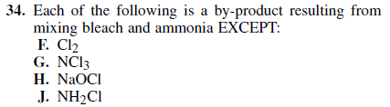

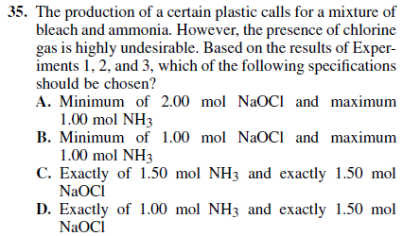
13

