Unit 5: Bonding

Free Response Review #1

Directions: The suggested time is about 15 minutes for answering the constructed response section of the chemistry test. The parts within a question may not have equal weight. For calculations, show all your work in the spaces provided after each part. Pay particular attention to the proper use of units. Be sure your final answer is rounded to the correct number of significant figures. Make sure your work is legible. Illegible work will receive a grade of zero.
Question 1 [8 POINTS]
The formulas and the boiling points at standard pressure for ethane, ethyne, methane, and methanol are shown in the table below.
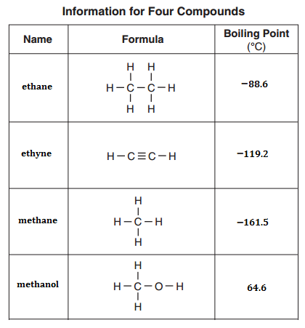
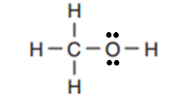
- Draw the complete Lewis electron-dot diagram for methane, CH₄, in the appropriate cell in the table above. [1 POINT]
  - Would you classify methane as a polar or nonpolar molecule? Justify your answer.
[1 POINT]

- Which of the four molecules contains the shortest carbon-to-carbon bond? Explain. [1 POINT]

- The normal boiling point of ethane is −88.6°C, whereas the normal boiling point of methanol is 64.6°C. Explain, in terms of the intermolecular forces present in each liquid, why the boiling point of methanol is so much higher than that of ethane. [2 POINTS]

- Energy is required to boil methanol. Consider the statement “As methanol boils, energy goes into breaking C−H bonds, C−O bonds, and O−H bonds.” Is the statement true or false? Justify your answer. [1 POINT]

- A Lewis electron-dot diagram of a molecule of ethanoic acid is given below. The carbon atoms in the molecule are labeled $x$ and $y$, respectively.

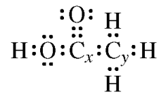
Identify the geometry of the arrangement of atoms bonded to each of the following.
- Carbon $x$ [1 POINT]

- Carbon $y$ [1 POINT]

