Unit 5: Bonding & Intermolecular Forces

Multiple Choice Practice
Directions: Each of the questions or incomplete statements below is followed by four suggested answers or completions. Select the answer that is best in each case and then fill in the corresponding circle on the answer sheet.

Note: For all questions, assume that the temperature is 298K, the pressure is 1.00 atm, and solutions are aqueous unless otherwise specified.
1
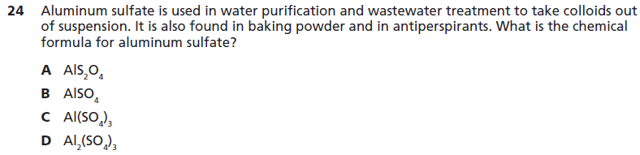
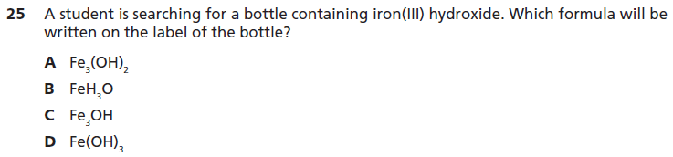
3
2
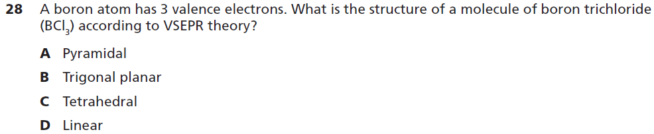
4
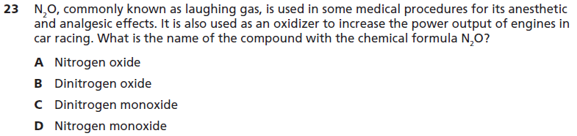
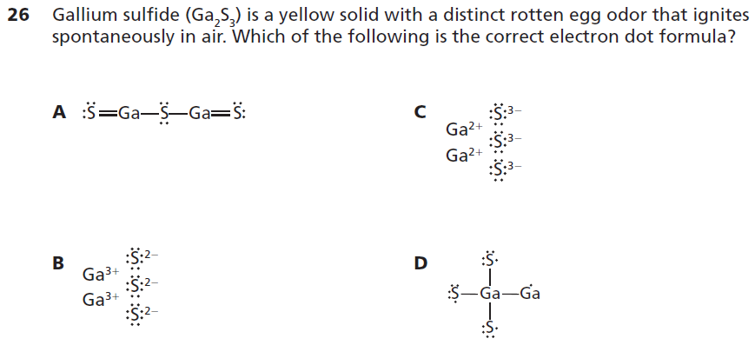
6
5
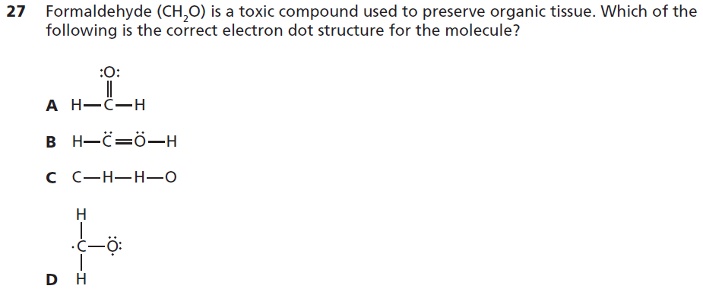
7
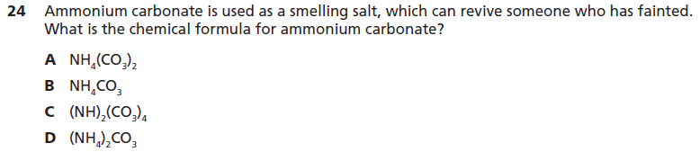
8
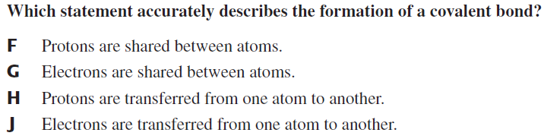
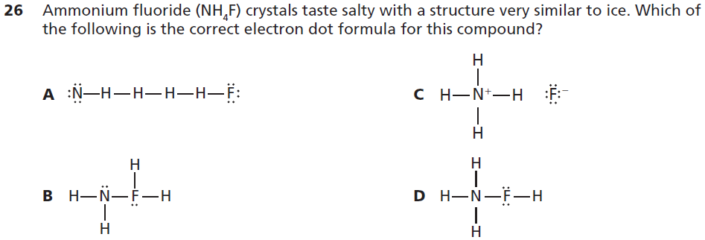
10
9
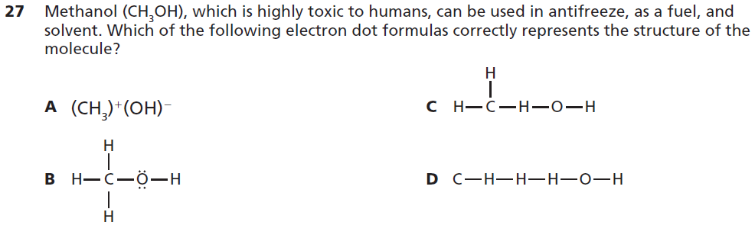
11
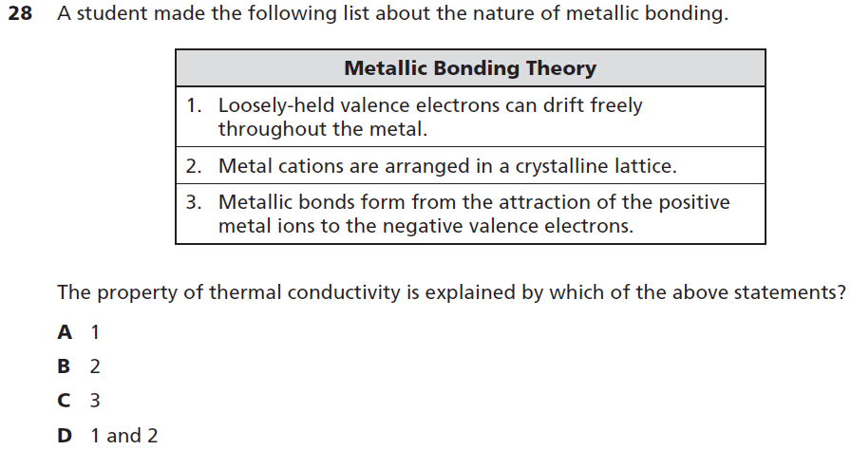
12
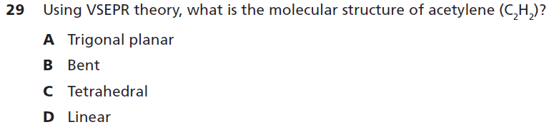
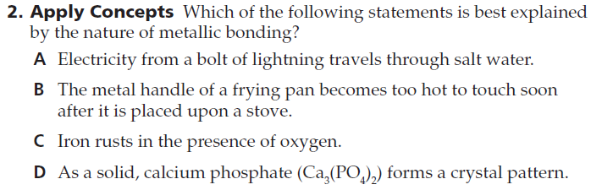
14
13
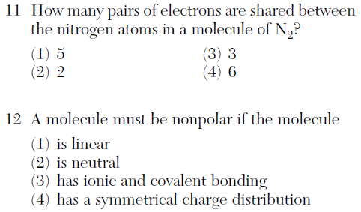
16
15
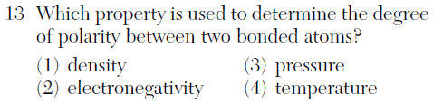
17
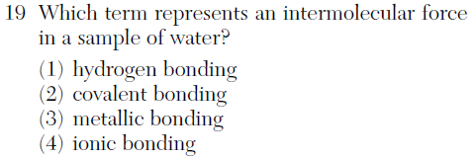
18
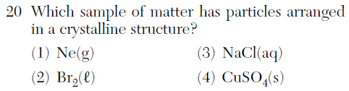
19
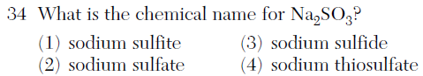
ACT Passage
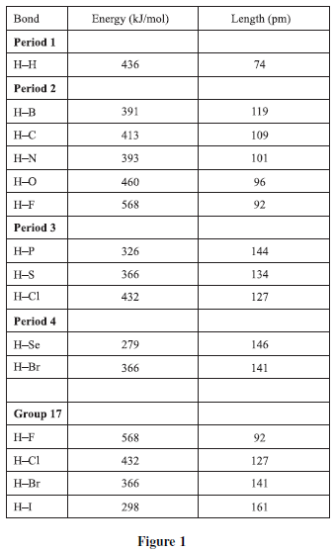
A chemical bond is the physical phenomenon of chemical substances being held together by attraction of atoms to each other through both sharing and exchanging of electrons or electrostatic forces. Bond energy is a measure of bond strength in a chemical bond. For example, the carbon hydrogen (C–H) bond energy is the energy change involved with breaking up the bond between the carbon and hydrogen atoms. Bonds with a higher energy release more energy when they form, and are considered to be more stable (less reactive). When reacting with nonmetals, hydrogen forms covalent bonds, meaning that the bonded atoms share electrons with each other. Figure 1 shows the bond energies and distances for bonds involving hydrogen and nonmetals (H–X). The chart is arranged by period (rows of periodic table); in addition, the values for group 17 (column 17 on the periodic table) are compared.

Bond length is the distance between two bonded atoms in a molecule. Bond lengths are measured in molecules by means of X-ray diffraction. A set of two atoms sharing a bond is unique going from one molecule to the next. For example, the oxygen to hydrogen bond in water is different from the oxygen to hydrogen bond in alcohol. It is, however, possible to make generalizations when the general structure is the same. Figure 2 relates bond energy to bond length for H–X bonds between hydrogen and nonmetals. The elements in each period or group are connected by a line (with the exception of the first, which contains only hydrogen).

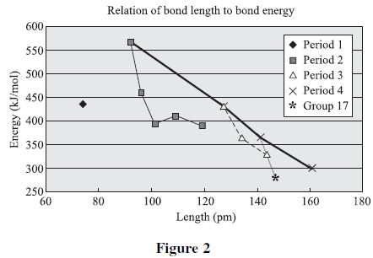
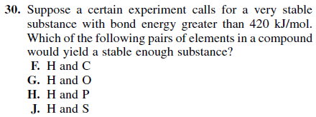
21
20
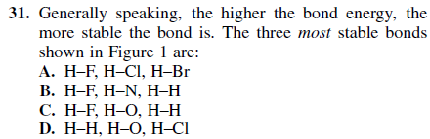
22
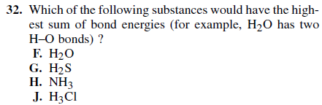
23
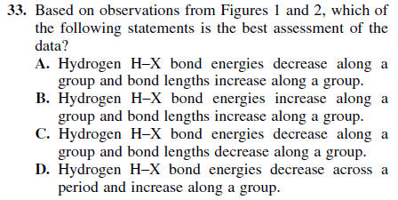
24
