Unit 5: Bonding & Intermolecular Forces

Multiple Choice Practice
Directions: Each of the questions or incomplete statements below is followed by four suggested answers or completions. Select the answer that is best in each case and then fill in the corresponding circle on the answer sheet.

Note: For all questions, assume that the temperature is 298K, the pressure is 1.00 atm, and solutions are aqueous unless otherwise specified.
1
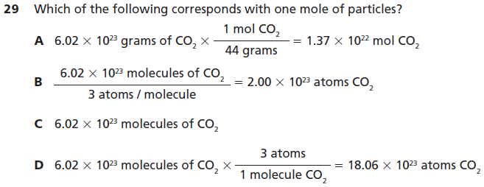
2
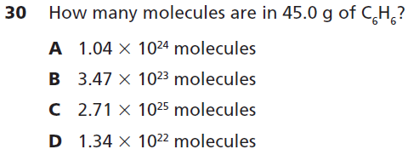
3
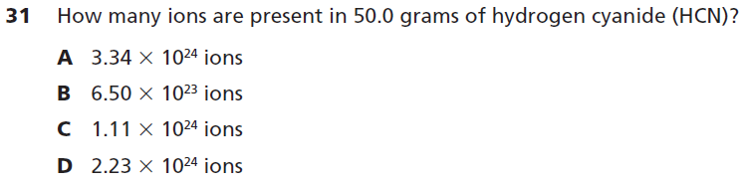
4
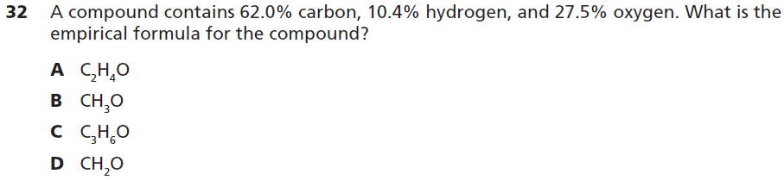
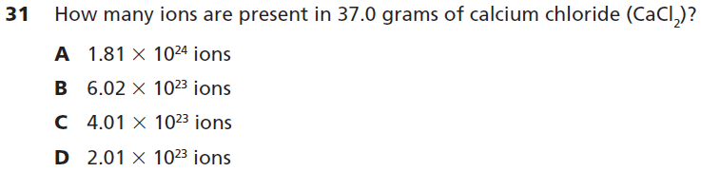
6
5
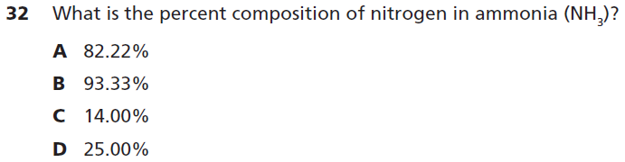
7
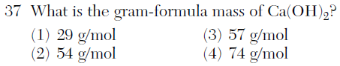
8
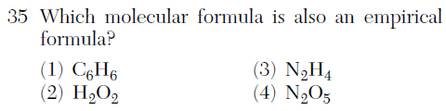
9
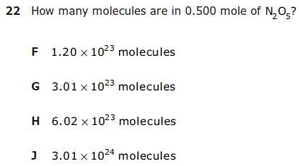
10
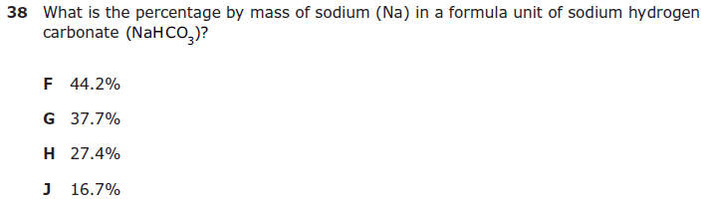

ACT Passage
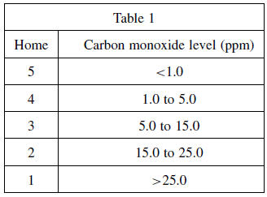
Carbon monoxide (CO) is a colorless, odorless gas produced by burning material that contains carbon, such as coal or natural gas. Carbon monoxide is the leading cause of accidental poisoning deaths in America. The Centers for Disease Control estimates that carbon monoxide poisoning claims nearly 500 lives and causes more than 15,000 visits to hospital emergency departments annually. Common household appliances produce carbon monoxide. When not properly ventilated, carbon monoxide emitted by these appliances can build up. The only way to detect carbon monoxide is through testing, using a specialized sensing device.

Gas stoves have been known to emit high levels of carbon monoxide. Average carbon monoxide levels in homes without gas stoves vary from 0.5 to 5.0 parts per million (ppm). Levels near properly adjusted gas stoves are often 5.0 to 15.0 ppm and those near poorly adjusted stoves may be 30.0 ppm or higher. CO levels between 0.5 and 15.0 ppm are considered safe. Table 1 shows the carbon monoxide levels in ppm for each of five homes, with and without gas stoves.

11
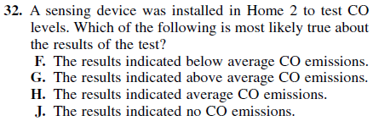
14

12
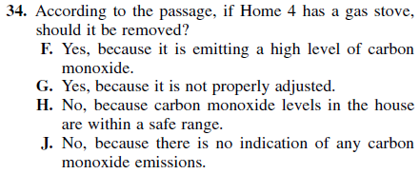
15

13
