Reactions
Unit 8
Practice Free Response 2

Directions: The suggested time is about 15 minutes for answering the constructed response section of the chemistry test. The parts within a question may not have equal weight. For calculations, show all your work in the spaces provided after each part. Pay particular attention to the proper use of units. Be sure your final answer is rounded to the correct number of significant figures. Make sure your work is legible. Illegible work will receive a grade of zero.
Question 1 [4 POINTS]
The reaction comprising the Haber process, important in artificial nitrogen fixation, is pictured below. The reactants of the Haber process are elemental nitrogen and elemental hydrogen.
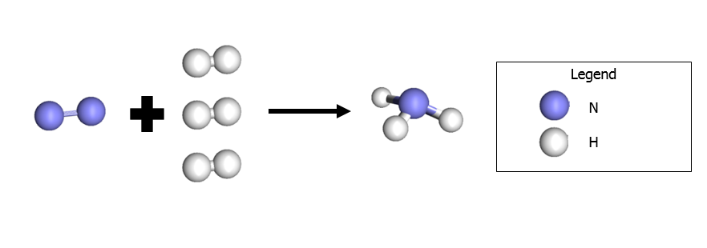
- Write the balanced chemical equation for the Haber process. [3 POINTS]

- In the Haber process, how many moles of elemental hydrogen are required to react with 1 mole of elemental nitrogen? [1 POINT]

CONTINUED ON REVERSE SIDE ☞

Question 2 [6 POINTS]
The reaction below occurs at room temperature. 24.8 g of calcium permanganate are mixed with 15.1 g of potassium chloride.
Ca(MnO₄)₂ (aq) + 2 KCl (aq) 2 KMnO₄ (aq) + CaCl₂ (aq)
- Which substance will be the limiting reactant? [3 POINTS]

- What is the theoretical yield, in grams, of calcium chloride? [2 POINT]

- If only 0.51 g of calcium chloride are formed, what is the percent yield? [1 POINTS]

