Unit 8: Stoichiometry

Multiple Choice Practice
Directions: Each of the questions or incomplete statements below is followed by four suggested answers or completions. Select the answer that is best in each case and then fill in the corresponding circle on the answer sheet.

Note: For all questions, assume that the temperature is 298K, the pressure is 1.00 atm, and solutions are aqueous unless otherwise specified.
1
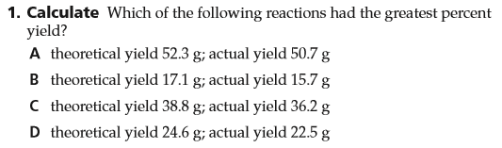

2
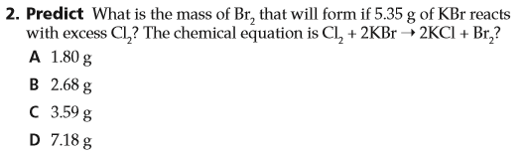
3
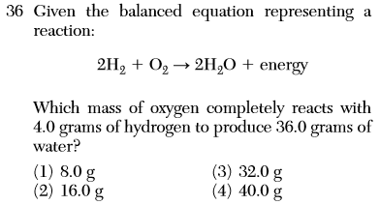
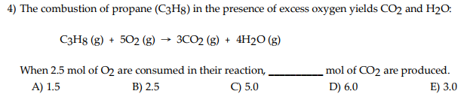
4

5

6

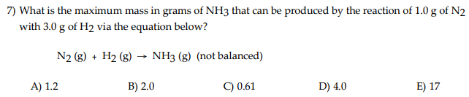
7

- Which of the following particulate diagrams best shows the formation of water vapor from hydrogen gas and oxygen gas in a rigid container at 125ºC?
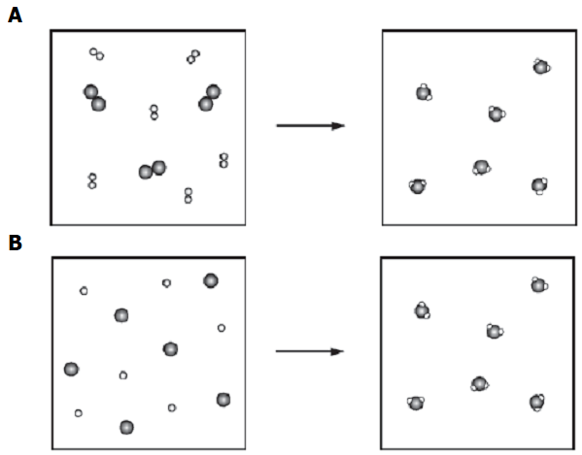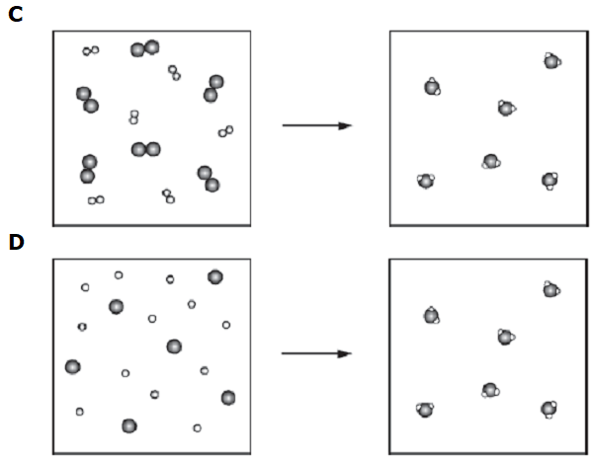

- Sulfuric acid is prepared commercially from elemental sulfur using the contact process. In a typical sequence of reactions, the sulfur is first burned:
$S\left(s\right)+O_{2}(g)→{SO}_{2}(g)$ ,
then it is converted to SO₃ using a catalyst:
$2 {SO}_{2}\left(g\right)+O_{2}\left(g\right)→2 {SO}_{3}(g)$ .
The resulting SO₃ is reacted with water to produce the desired product:
${SO}_{3}(g) +H_{2}O(l)→H_{2}{SO}_{4}(aq)$
How much sulfuric acid could be prepared from $1.28×{10}^{8}$ g of sulfur? Answer in units of grams.

- $4.18×{10}^{11}$ g b. $3.02×{10}^{14}$ g c. $3.92×{10}^{8}$ g d. $9.81×{10}^{12}$ g

