Unit 9: Gases

Multiple Choice Practice
Directions: Each of the questions or incomplete statements below is followed by four suggested answers or completions. Select the answer that is best in each case and then fill in the corresponding circle on the answer sheet.

Note: For all questions, assume that the temperature is 298K, the pressure is 1.00 atm, and solutions are aqueous unless otherwise specified.

1
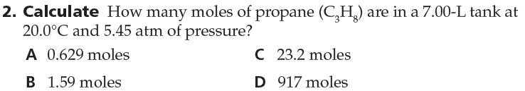
2
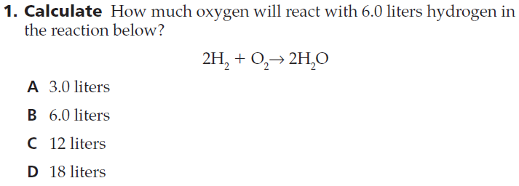
3
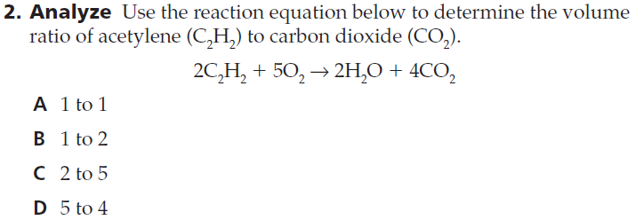
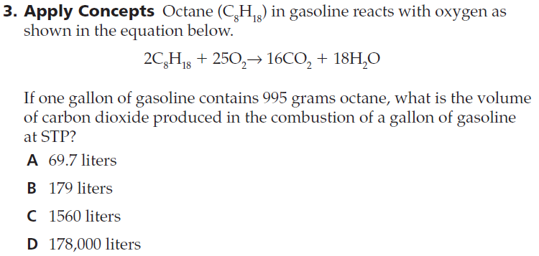
4
5
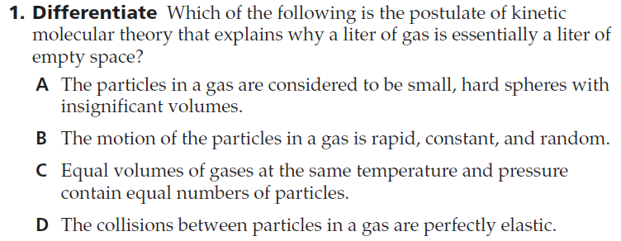
6
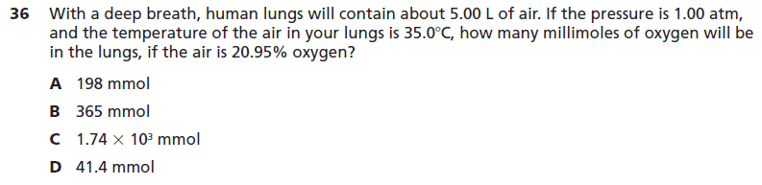

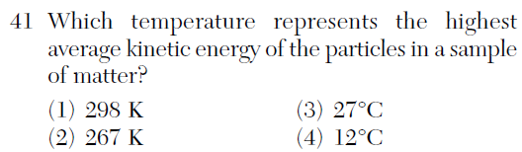
7
8
10
9
11
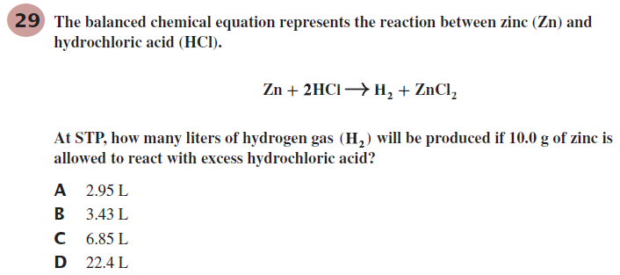
12

