Unit 9: Gases

Multiple Choice Practice
Directions: Each of the questions or incomplete statements below is followed by four suggested answers or completions. Select the answer that is best in each case and then fill in the corresponding circle on the answer sheet.

Note: For all questions, assume that the temperature is 298K, the pressure is 1.00 atm, and solutions are aqueous unless otherwise specified.

1
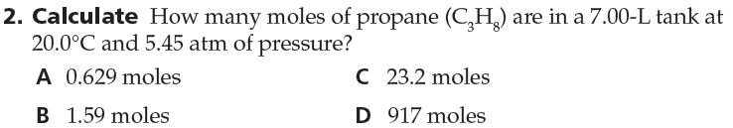
2
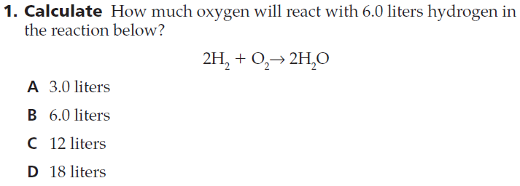
3
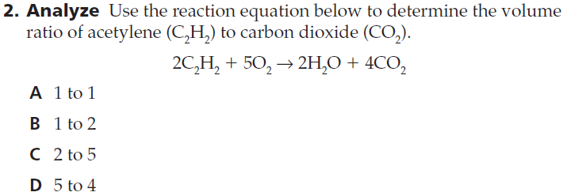
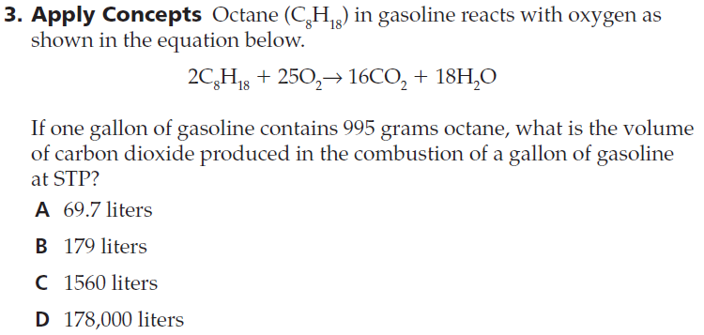
4
5
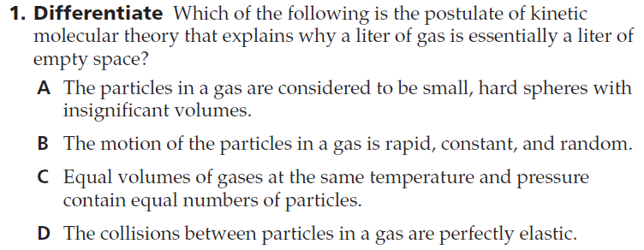
6
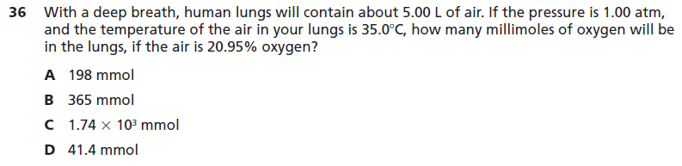

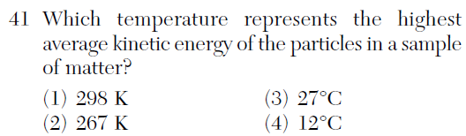
7
8
9
10
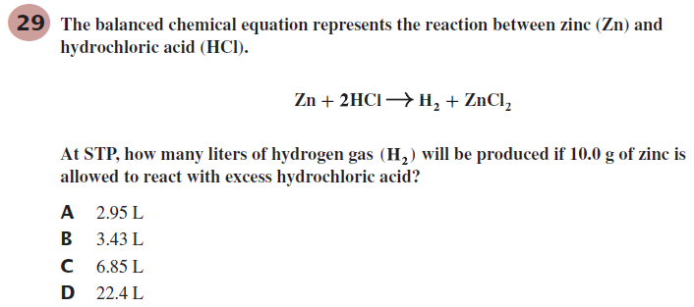
11
- Assume the amount of gas is constant. If the temperature increases and the pressure stays the same, then what will happen to the volume of a non-rigid container?
  - stay the same b. increase c. decrease
- Each of the flasks above contains the same number of molecules. In which container is the pressure the lowest?
  - Flask 1 b. Flask 2 c. Flask 3 d. Flask 4
- One way to increase pressure on a gas is to:
  - decrease temperature c. increase the number of gas particles
  - increase volume d. lower the kinetic energy of the gas particles
- How do gas particles response to an increase in volume?
  - increase in kinetic energy and decrease in temperature
  - decrease in kinetic energy and decrease in pressure
  - increase in temperature and increase in pressure
  - decrease in kinetic energy and increase in temperature
- Each of these flasks is the same size and at the same temperature. Which one contains the most molecules?
  - Flask 1 b. Flask 2 c. Flask 3 d. Flask 4
- Because ideal gases have inelastic collisions, when two gas particles collide:
  - They bounce off each other with no loss in energy.
  - They bounce off each other with a small loss in energy.
  - They bounce off each other with a large loss in energy.
  - They bounce off each other with a small increase in energy.
- If all of these flask are the same size, at the same temperature, and contain the same number of molecules, in which flask will the molecules be moving the slowest?
  - Flask 1 b. Flask 2 c. Flask 3 d. All move at the same speed.

- Which of the following has the most molecules?
  - 1.00 L of CH₄ at 0ºC and 1.00 atm c. 1.00 L of CO₂ at 20ºC and 1.00 atm
  - 1.00 L of N₂ at 0ºC and 1.00 atm d. 1.00 L of CO at 0ºC and 1.25 atm
- If all of these flask are the same size, at the same temperature, and contain the same number of molecules, in which flask will the pressure be the highest?
  - Flask 1 b. Flask 2 c. Flask 3 d. All have the same pressure.

- Avogadro stated that equal volumes of gases under the same conditions of temperature and pressure have equal:
  - number of molecules c. number of atoms
  - number of grams d. molar masses

