Unit 9: Gas Laws and Gas Stoichiometry

Pre-AP Chemistry Free Response Review #1

Directions: The suggested time is about 15 minutes for answering the constructed response section of the chemistry test. The parts within a question may not have equal weight. For calculations, show all your work in the spaces provided after each part. Pay particular attention to the proper use of units. Be sure your final answer is rounded to the correct number of significant figures. Make sure your work is legible. Illegible work will receive a grade of zero.
Question 1 [10 POINTS]

2 H₂O₂(aq) 2 H₂O(l) + O₂(g)

An aqueous solution containing 0.4969 g H₂O₂ decomposes completely according to the reaction represented above. The O₂(g) produced is collected in an inverted graduated cylinder over water at 23.4ºC and has a volume of 0.1824 L when the water levels (or height of the water) inside and outside of the cylinder are the same. The atmospheric pressure in the lab is 762.6 torr.

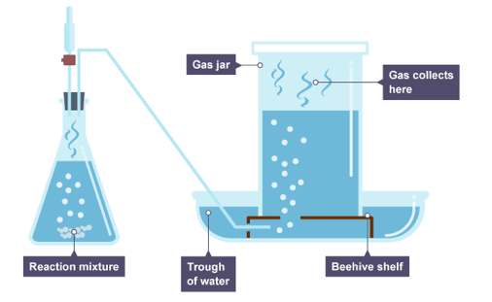

- Calculate the number of moles of O₂(g) produced in the reaction. [2 POINTS]
- Calculate the number of molecules of O₂(g) produced in the reaction. [2 POINTS]
- Calculate the partial pressure, in torr, of O₂(g) in the gas-collection cylinder. [2 POINTS]
- Calculate the vapor pressure of water at 23.4ºC (in torr). [2 POINTS]
- Calculate the moles of water vapor present in the gas collection cylinder. [2 POINTS]

